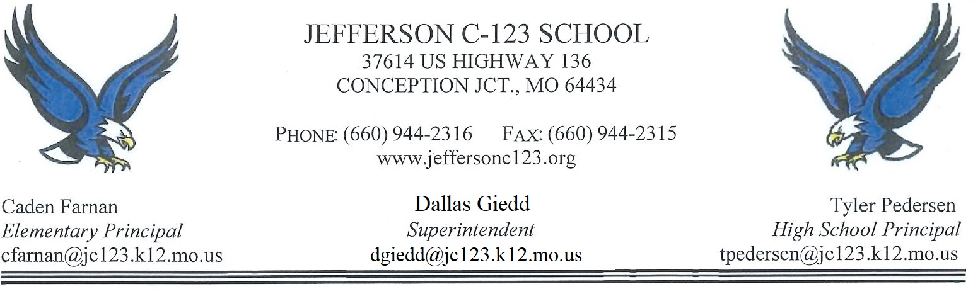

**EMPLOYMENT APPLICATION**

*Jefferson C-123 School District Board of Education considers all applicants for all positions without regard to race, color, religion, sex, national origin, ancestry, age, marital status, pregnancy, exercise of FMLA rights of disability in employment, educational programs or activities set forth in policy AC. If you have a disability or handicap which may require special accommodations for you to participate in our application process (including filling out this form, interviewing or any other pre-employment procedure or requirement), please make us aware so that we may assist you to the best of our ability. If you have any inquiries, complaints or concerns about any pre-employment procedure or requirement, including filling out this application, or about the District policy of non-discrimination, you may contact the Superintendent at Jefferson C-123 Schools.*

**Personal Data**

Please print or type.

Name: ______________________________________________________________________________________

Present Address: ______________________________________________________________________________

Street Apt. #

____________________________________________________________________________________________

City State Zip

Home Phone: _(___)______________ Business Phone: __(___)_______________ OK to call? ___ Yes ___ No

Position(s) applying for: ________________________________________________________________________

What salary requirements would you expect? _______________________________________________________

Extra duty positions you may be interested in sponsoring or coaching? ___________________________________

**EDUCATION**

|  |  |  |  |  |
| --- | --- | --- | --- | --- |
| **High School(s)** | **Location** | **# of Years**  **Attended** | **Diploma**  **Received** | **Major &**  **Minor** |
|  |  |  |  | N/A |
|  |  |  |  | N/A |
| **Colleges/**  **Universities** | **Location** | **# of Years**  **Attended** | **Degree** | **Major &**  **Minor** |
|  |  |  |  |  |
|  |  |  |  |  |

**WORK EXPERIENCE**

Please include military experience.

|  |  |  |  |
| --- | --- | --- | --- |
| Business & Address | Phone | Occupation | Years of Service |
|  |  |  |  |
|  |  |  |  |
|  |  |  |  |
|  |  |  |  |
|  |  |  |  |

**SKILLS**

List any skills pertaining to the position(s) applying for:

______________________________________________________________________________

______________________________________________________________________________

______________________________________________________________________________

**REFERENCES**

Please list at least 3

|  |  |  |  |
| --- | --- | --- | --- |
| Name | Position | Telephone | Address |
|  |  |  |  |
|  |  |  |  |
|  |  |  |  |
|  |  |  |  |

**QUESTIONS**

4. If job requires you to transport students, drive school vehicles, or operate machinery, please list traffic offenses:

____________________________________________________________________________________________

____________________________________________________________________________________________

I verify that each and every question on this application has been answered accurately and completely. I understand that false, inaccurate, or misleading information is grounds for rejection of this application or termination of my employment.

_________________________________________ ­­­­­­­­___________________________

Signature Date

Yes No

* 🞎

🞎 🞎

🞎 🞎

1. Have you ever been charged with, convicted or entered a plea, including a plea of nolo contendere, to any felony or misdemeanor, whether or not sentence was imposed, expunged, or suspended and any other type of driving offense such as DWI (Driving While Intoxicated), or DUI (Driving Under the Influence) excluding minor traffic violations? If yes, explain.

2. Have you ever been denied a professional license, certificate, permit, credential, endorsement or registration?

3. Have you ever resigned, been restricted, disciplined, or discharged from any position, including the armed forces, while under suspicion of having engaged in criminal, immoral, unethical behavior, or unprofessional conduct, or are you under investigation for any such charge?

The following questions are designed to assist the screening committee in the selection process. Your concise and candid responses are important. Please answer in your own handwriting.

1. What are your strengths or positive personal qualities?

2. What areas would you like to improve?

3. Why do you want a position with Jefferson C-123 Schools?

4. Give any other information you feel would be important to the selection committee.

Please address communication to:

Dallas Giedd, Superintendent

Jefferson C-123 Schools

37614 U.S. Hwy. 136

Conception Jct., MO 64434

*This application will be kept on file at Jefferson for six months past the date signed by applicant.

For office use: Interviewed ______________________ Date ___________ Recommendation __________